FitLore Rescue
  - Week 3 project report
FitLore Rescue helps a stylist recover a fashion shoot when its hero jacket becomes unavailable. It investigates affected looks, checks replacement garments against the brief, and waits for human approval before updating the local production plan.
The prototype completed a live recovery after an injected inventory failure. A second live run found no qualifying replacement and handed control back without changing the plan. These two runs demonstrate specific behaviors; they do not establish a general success rate.

The problem and the user
A stylist must connect a garment change to every affected look, check the brief and timing, compare options, and obtain approval. FitLore keeps that investigation and its evidence in one workspace. The demo uses a fictional campaign called The Monday Edit.

The demonstration
Before | After approval
Hero navy blazer G01 is unavailable | Studio navy blazer G02 replaces G01
Two looks are blocked | Both looks reference the approved replacement
Replacement ceiling is $60 | Recorded replacement cost is $45
Stylist and photographer reviews are open | Both reviews remain open

What changed from Week 2
Week 2 established FitLore’s styling and production-planning concept. This focused companion build reuses its visual identity and licensed category photography. The new work is a model-selected tool loop, persistent approval, failure handling, and an atomic plan update. It does not migrate the previous database.

Success criterion
A valid recovery ends with a reviewed plan update, or a specific handoff when no safe replacement exists. No unapproved or invalid replacement may be applied. The next evaluation target is ten varied scenarios with measured completion time; that larger evaluation has not yet been run.

Architecture and control
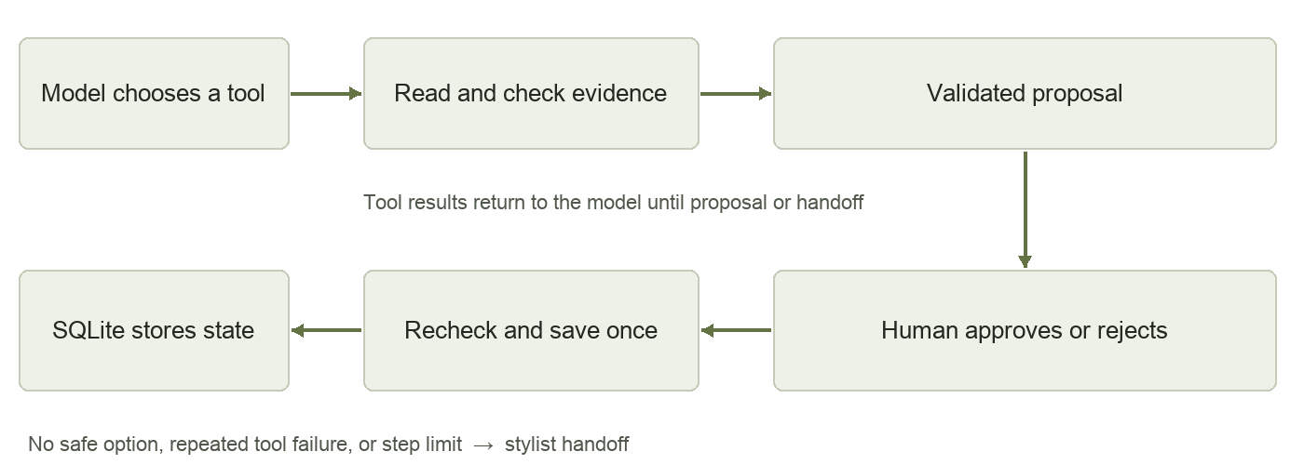
The model selects one allowlisted tool at each step. Tool results return to the model. Python enforces the hard constraints, and LangGraph saves state between nodes. An approval interrupt persists until the user approves or rejects the proposal.
Component | Configuration or role
Model | Qwen/Qwen3-30B-A3B-Instruct-2507 through Nebius Token Factory
Orchestration | Python LangGraph 1.2.17; schema-constrained action selection
Persistence | SQLite workspace and LangGraph SQLite checkpointer
Interface | FastAPI with local HTML, CSS and JavaScript
Retrieval | Structured local records; no vector index or embeddings in this workflow
Request limits | 20 model attempts for this authorized session; 10 steps per run

Tools and the write boundary
read_shoot, inspect_impact and search_wardrobe read the evidence. check_replacement validates category, availability, color, recorded size, sleeve coverage, timing and cost. propose_replacement prepares an approval request. handoff stops with an explanation.
The model cannot directly write the plan. After approval, the transaction rechecks the project revision and candidate constraints. A unique run identifier prevents a repeated apply from duplicating the update. Rejection leaves the plan unchanged.

Failure handling and memory
The inventory demonstration permits one retry and hands off after two failures. Model service errors and a ten-step limit also stop safely. Run observations, approval state, and event history survive reopening. This is durable workflow memory, not learned user preferences.

Evidence and limitations

Data used
Data | Origin and scope
Shoot brief | Fictional local brief with a $60 replacement ceiling and 10:00 call time
Wardrobe | Eight fictional garment records, including five jackets and three supporting items
Production | Two looks that share the jacket at separate slots, plus two review tasks
Photography | Three existing FitLore category photos; Pexels credits are included in the app
Evaluation | Deterministic test cases and two saved live Nebius investigations

Observed live results
Scenario | Observed outcome | Requests
Inventory fails once | Recovered; human approval updated both looks | 7
No suitable replacement | Rejected unsuitable candidates; handed off without a write | 7

The recovery run unnecessarily reread the brief once. In the no-match run, the model initially selected a late-arriving jacket and then an unavailable jacket. Code rejected both. The final handoff correctly identified the timing, availability, color and size conflicts. All 14 requests count toward the 20-request allowance.

Automated verification
17 automated tests passed. They cover approval, duplicate writes, rejection, checkpoint reopening, transient and permanent failure, no-match handoff, stale approval, changed availability, invalid candidates, skipped evidence, provider failure and the request ceiling. The tests use a deterministic decision driver; they do not measure model quality.

Practical limits
This is a single-user localhost prototype with fictional inventory. It does not verify retailer stock, analyze garment images, guarantee physical fit, reserve garments, send messages or spend money. Each investigation starts an independent scenario copy. Fit and photographer approval remain human tasks. Remote deployment and multi-user authentication are outside this build.

Prompts iterations and learnings

How AI coding tools were used
Codex inspected the previous FitLore implementation, translated the Week 3 handout into a bounded rescue workflow, wrote the backend and interface, and tested the browser flow. The user selected FitLore and authorized up to 20 Nebius requests for fictional demo data.

Build instructions and runtime prompt
The user’s project direction was “lets build on fitlore”. The build focused on this request: “The hero jacket is unavailable. Rescue tomorrow’s shoot within the brief and budget.”
The runtime system prompt requires one JSON tool decision, treats source text as untrusted data, lists the allowed tools, requires evidence and a successful candidate check before proposing, limits inventory retries, and requires handoff when no garment qualifies. The complete prompt is versioned in app/agent.py.

Iterations completed
Iteration | Change and reason
Focused scope | Built a companion rescue workflow instead of expanding all Week 2 features
Control layer | Added required-evidence checks, candidate validation, a saved approval interrupt, and an idempotent transaction
Verification | Added failure, stale-plan and provider-error tests; exercised two real model runs
Browser refinement | Bounded the timeline height, improved replacement-image framing, and fixed polling of the intermediate approved state

What the work showed
Structured model output constrains the action format, but it does not make the decision correct. The no-match run demonstrated why the application must validate availability and timing before offering a write. Durable approval state also makes the workflow easier to demonstrate and resume.
Next improvements are broader live evaluation, fewer repeated reads, editable shoot constraints, and an authenticated inventory integration. Those are future work, not current capabilities.

Technical references
LangGraph interrupts: https://docs.langchain.com/oss/python/langgraph/interrupts
LangGraph persistence: https://docs.langchain.com/oss/python/langgraph/persistence
Photo source links: web/images/credits.json
Live run evidence: output/submission/live-evidence.json

